**Klasifikasi Data Indian Liver Patient Dataset (ILPD)**

**dataset = read.csv('Indian Liver Patient Dataset (ILPD).csv')**

**# Encoding the target feature as factor**

**dataset$X1 = factor(dataset$X1, levels = c(2, 1))**

**# Splitting the dataset into the Training set and Test set**

**# install.packages('caTools')**

**library(caTools)**

**set.seed(123)**

**split = sample.split(dataset$X1, SplitRatio = 0.75)**

**training_set = subset(dataset, split == TRUE)**

**test_set = subset(dataset, split == FALSE)**

**# Feature Scaling**

**training_set[1] = scale(training_set[1])**

**test_set[1] = scale(test_set[1])**

**# Fitting Naive Bayes to the Training set**

**library(e1071)**

**classifier = naiveBayes(x = training_set[-3],**

**y = training_set$X1)**

**# Predicting the Test set results**

**y_pred = predict(classifier, newdata = test_set[-3])**

**y_pred**

**# Making the Confusion Matrix**

**cm = table(test_set[, 3], y_pred)**

**cm**

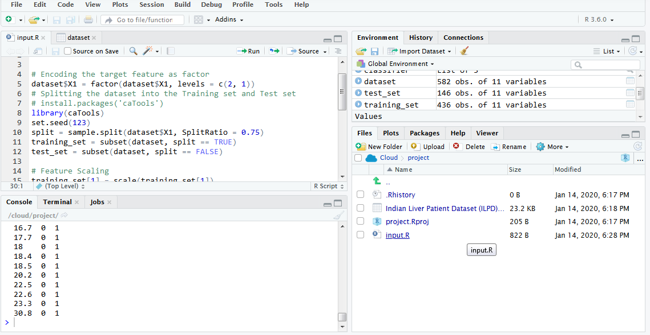

**> dataset = read.csv('Indian Liver Patient Dataset (ILPD).csv')**

**> View(dataset)**

**> # Encoding the target feature as factor**

**> dataset$Famale = factor(dataset$Famale, levels = c(2, 1))**

**Error in `$<-.data.frame`(`*tmp*`, Famale, value = integer(0)) :**

**replacement has 0 rows, data has 582**

**> # Encoding the target feature as factor**

**> dataset$X1 = factor(dataset$X1, levels = c(2, 1))**

**> # Splitting the dataset into the Training set and Test set**

**> # install.packages('caTools')**

**> library(caTools)**

**> set.seed(123)**

**> split = sample.split(dataset$X1, SplitRatio = 0.75)**

**> training_set = subset(dataset, split == TRUE)**

**> test_set = subset(dataset, split == FALSE)**

**> # Feature Scaling**

**> training_set[-1] = scale(training_set[-1])**

**Error in colMeans(x, na.rm = TRUE) : 'x' must be numeric**

**> # Feature Scaling**

**> training_set[1] = scale(training_set[1])**

**> test_set[1] = scale(test_set[1])**

**> # Fitting Naive Bayes to the Training set**

**> library(e1071)**

**> classifier = naiveBayes(x = training_set[-3],**

**+ y = training_set$X1)**

**> # Predicting the Test set results**

**> y_pred = predict(classifier, newdata = test_set[-3])**

**> y_pred**

**[1] 1 1 1 1 2 1 1 1 1 1 2 2 1 1 1 1 2 1 2 1 1 1 1 1 1 1 1 2 2 1 1 1**

**[33] 1 1 2 2 1 1 1 1 1 1 1 1 1 1 1 1 2 1 1 2 2 1 2 1 1 2 1 1 1 2 1 1**

**[65] 1 1 1 2 2 1 1 1 2 1 2 1 2 2 1 1 1 2 1 1 2 2 1 1 1 2 1 1 1 2 2 1**

**[97] 2 1 1 1 1 2 1 1 2 2 2 1 1 1 1 2 2 1 1 2 1 1 1 2 2 1 1 1 1 1 1 2**

**[129] 1 2 1 1 2 1 2 1 1 1 1 1 1 1 1 1 2 2**

**Levels: 2 1**

**> # Making the Confusion Matrix**

**> cm = table(test_set[, 3], y_pred)**

**> cm**

**y_pred**

**2 1**

**0.5 1 0**

**0.6 4 6**

**0.7 10 7**

**0.8 13 16**

**0.9 3 8**

**1 3 2**

**1.1 1 4**

**1.2 0 2**

**1.3 1 1**

**1.4 2 3**

**1.5 1 0**

**1.6 2 0**

**1.7 0 4**

**1.8 1 2**

**2 0 2**

**2.2 0 4**

**2.3 0 1**

**2.4 0 1**

**2.6 1 0**

**2.8 0 1**

**2.9 0 5**

**3 0 1**

**3.1 0 2**

**3.5 0 1**

**3.9 0 3**

**4.1 0 2**

**4.2 0 1**

**4.9 0 1**

**5.2 0 1**

**5.7 0 1**

**5.8 0 2**

**6.7 0 1**

**6.8 0 1**

**7.3 0 1**

**8.6 0 1**

**8.7 0 1**

**10.6 0 1**

**11.1 0 1**

**12.7 0 1**

**16.4 0 1**

**16.7 0 1**

**17.7 0 1**

**18 0 1**

**18.4 0 1**

**18.5 0 1**

**20.2 0 1**

**22.5 0 1**

**22.6 0 1**

**23.3 0 1**

**30.8 0 1**